Unit2 Rules around us
单元主题（守则与制度）阅读回答问题 16 篇（分层练习）
Every home should have its family rules.There is a book about family rules called Rules of Love.It says family
rules help to make home a better place.In our family, we tape(粘贴) our rules on the wall of the living room.I got
them from a friend six years ago, and these rules help us a lot over the years.We tell our children that the family
rules follow them wherever(无论何处) they go.These are not just rules for them to follow at our house.
Rules come in different words.But good rules are all easy to understand.And it is important for the children
to remember and follow the rules.So don’t have too many rules for your children.For younger children, parents can
use pictures to tell them about the rules.
Here are some examples(例子):
* Sit down to eat.
* No fighting.No name-calling(骂人).
* Don’t ask for things in the supermarket.
1．What’s the name of the book？
___________________________________________________________________
2．Where does the writer(作者)tape the rules?
___________________________________________________________________
3．When did the writer get the family rules?
__________________________________________________________________
4．What can parents use to tell younger children the rules?
__________________________________________________________________
5．How many family rules are mentioned(被提及)?
__________________________________________________________________
Now, there are more and more food deliverymen (外卖送餐员) around us. They wear blue, red or yellow
clothes and they often drive a motorbike. And most of them are always in a hurry.
Some of them often break traffic (交通) rules. They drive fast on the road and run red lights. Some even
make calls when driving. In 2021, the food deliverymen had 176 traffic accidents in Shanghai, according to Xinhua
同步新教材，周周有练习，月月有重点！ 1

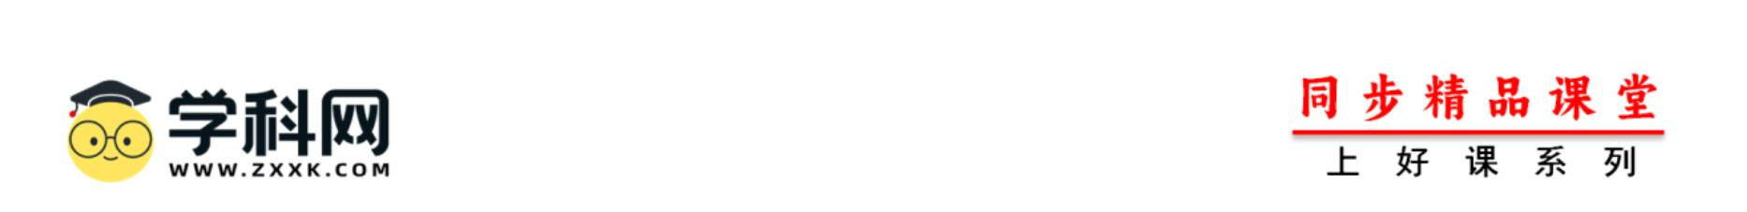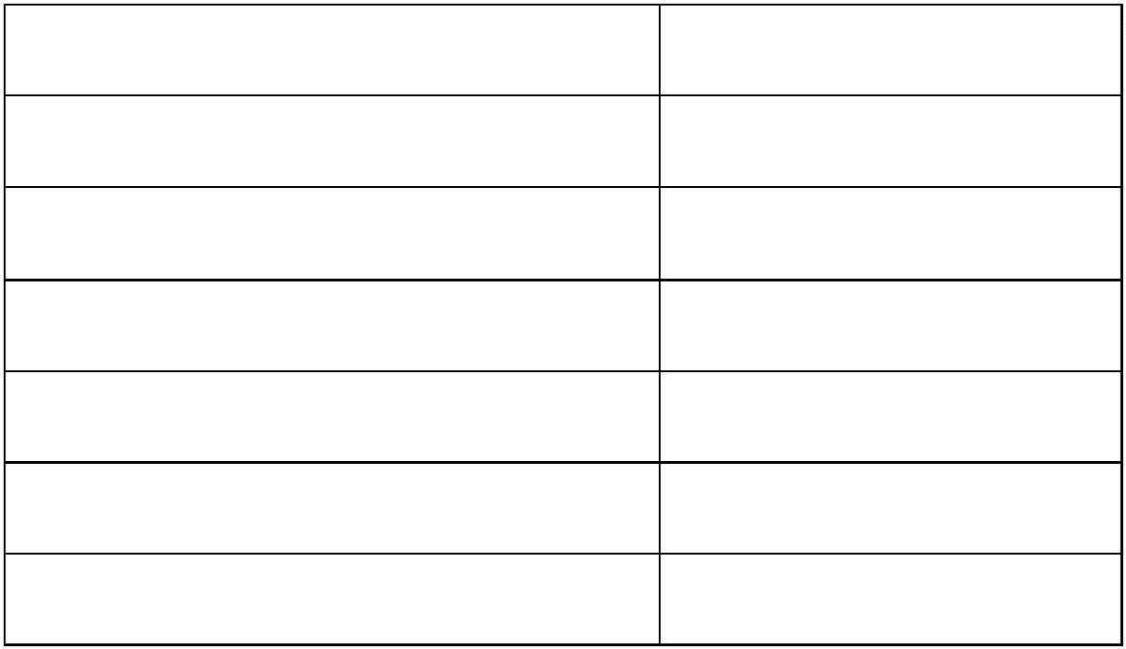Newspaper. That means every two and a half days, someone gets hurt on the road.
Why are they always in such a hurry and some even put themselves into such danger? Many food delivery
companies (公司) have many strict rules for them. For example, many companies will fine (罚款) a deliveryman if
he can’t deliver an order on time. Also, many of them wish to take more orders and make more money.
People believe food delivery service companies need to do something. Shanghai asks companies to teach
their deliverymen traffic rules. And in Shenzhen, if a deliveryman breaks traffic rules three times, then he can’t do
the job for the year. At the same time, we wish companies and people can give deliverymen more time on the street.
1．Are there more and more food deliverymen around us now?
2．How many accidents do deliverymen have in Shanghai in 2021?
3．Why are some deliverymen always in a hurry?
4．If your order is late, will you give bad reviews to the deliveryman? Why or why not?
The Wenhua School’s Rules
You must You mustn’t
Arrive at school by half past seven every morning. Wear jeans.
Hand in your homework before eight. Eat or drink in the classroom.
Look clean and tidy. Bring phone to school.
Listen carefully in classes. Run or talk in the school buildings.
Stay on the playground at break time. Talk loudly in the hallways.
Stand up when a teacher comes into the classroom. Fight.
阅读下面的短文，然后根据短文内容回答问题。
1．What can you do in classes?
同步新教材，周周有练习，月月有重点！ 2

2．What can’t you do when you are in the school building?
3．Can you bring the phones to school?
4．What do you do when your teacher comes into the classroom?
5．Can you fight in the school?
阅读短文，然后根据短文的内容，简要回答下列问题。
Do you feel angry if someone plays loud music or videos when you are in the subway? It’s not a problem for
people in Shanghai now.
Some new rules for the Shanghai subway came into force (开始生效) on December 1,2020. One of them is
“No using loudspeakers (扬声器)”. Subway riders have to use their earphones (耳机) when they listen to music or
watch movies on their phones. People must follow this rule when they take the subway. Those who break the rule
will be stopped by subway workers. If they don’t listen to the workers, they will be handed over to the police.
There are also some other rules: People cannot bring bikes into the subway station, people cannot eat or drink
in subway cars and so on.
People can see the signs around the subway station and in subway cars. The local government hopes the new
rules can create a better environment for the subway riders.
Many people welcome the new rules. They hope there are the same rules on buses and trains.
1．When did the new rules come into force?
2．Will subway workers stop those who use loudspeakers when taking the subway?
3．How many new rules are mentioned (被提及) in the passage?
4．What does the local government want to do with the new rules?
5．What do you think of the new rules?
同步新教材，周周有练习，月月有重点！ 3

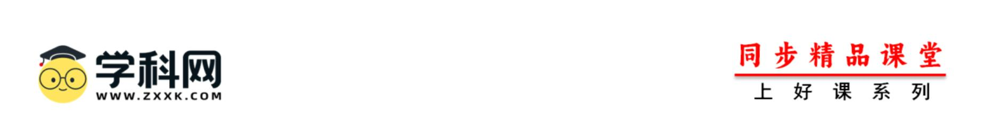Do you obey the rules in your school? How do you like your school rules? A lot of school rules are similar
around the world, but some are different. Every school has their own rules.
There are some rules in Japanese schools. The students are not allowed to dye(染) their hair and should keep
the hair Japanese black color. They are not allowed to wear earrings, either. Almost all schools required students to
wear uniforms in the past but now half of the schools require uniforms. The students feel happy to wear all kinds of
clothes. The students mustn’t be late for school. If they are late, they can’t get into the school gate because the
school gate is closed. In Japan, students are not allowed to have part-time jobs because they may not concentrate on
their study.
American schools have their own rules. For example, in Morton High School, students are not allowed to
choose their own clothes. They must get to school and leave school on time. They must wear sports shoes in gym
class. They should keep quiet in the school bus. In America, the students can have part-time jobs in their free time.
根据短文内容，回答下列问题。
1．Are you allowed to wear earrings if you are a student in Japan?
2．Why are the students not allowed to have part-time jobs in Japan?
3．Japanese schools and Morton High School don’t have the same rule, do they?
4．What must the students in Morton High School wear in gym class?
5．There must be some rules in your school. Give one example, please.
Schoolwork is becoming more and more difficult for students now. Recently, some new rules (规定) have
been made to make them have a happy school life.
These new rules are made for schools in Jiangsu province. They include some parts. For example, teachers of
primary and junior high schools can’t reveal(公布) students’ test scores. They should use letters like A and B to
grade students’ test results.
同步新教材，周周有练习，月月有重点！ 4

Because of COVID-19, students spent a long holiday at home. After the new term started, some schools might
give more homework or classes to students. But the new rules ask schools not to do that. At the same time, students
should have music, sports and art classes as usual.
People have different ideas about the new rules. Yin Fei, a college professor, says some students are not good
at studying, but they can do well in other things. So it is good to cancel(取消) scores. But Peng Ming, a teacher in
Nanjing, worries about that. He thinks scores are still important. Students need to get high scores to enter good
colleges and parents care about their children’s scores. So the new rules are not so good for them.
根据短文内容回答问题。
1．In which place can’t teachers reveal students’ test scores?
2．How should teachers there grade students’ test results?
3．Can schools there cancel P. E. classes in the new term?
4．What does Yin Fei think of the new rules?
5．Why does Peng Ming worry about the new rules?
Do you have family rules? Do you think they are good or terrible? Frank is a middle school student. He is
always happy with his family rules. Do you want to know what the rules are?
Take exercise every day. On weekdays, Frank always plays tennis with his classmates for half an hour after
school. And his parents run in the morning. On weekends, Frank’s family often play sports together.
Let evening time only be family time. They can’t watch TV or play games after dinner. The family usually
sit on the sofa and have a talk. Frank likes to talk about his school and friends. Sometimes they take a walk to the
park.
Always say “I love you” and “Thank you”. Frank says “I love you” to his parents every morning before he
goes to school and every night before he goes to bed. And his parents say it to him, too. When they get help from
other family members, they must say “Thank you”.
Frank likes every rule in his family because he thinks his family rules help him to keep healthy. Many
同步新教材，周周有练习，月月有重点！ 5

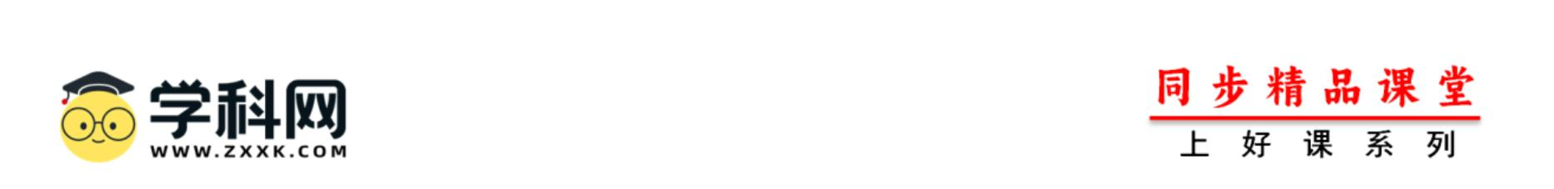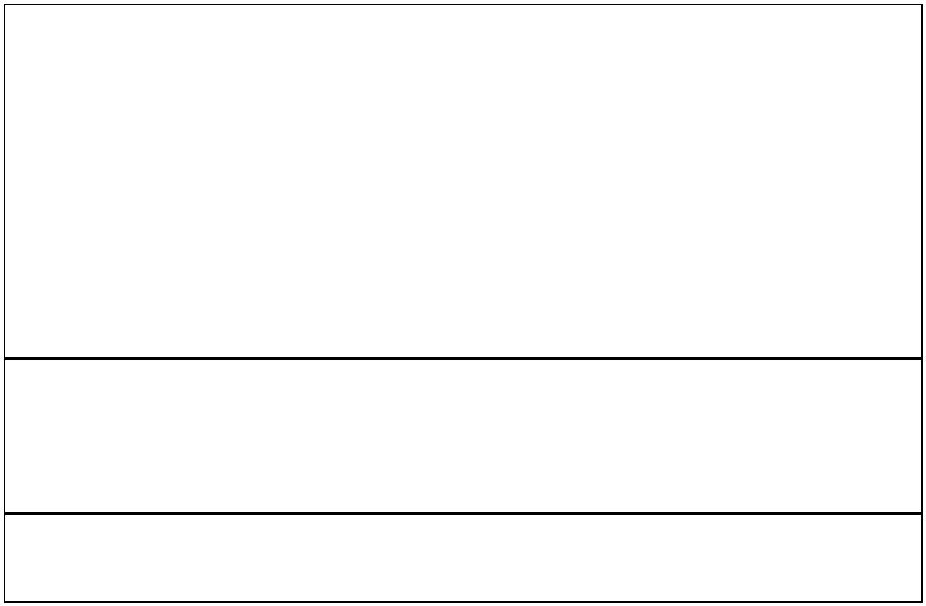students don’t like doing sports but Frank is different. He is good at sports and he looks healthy. And these rules
also let his family live a happy life. To follow the rules, they must show their love and thanks to each other every
day.
1．Do Frank’s parents say “I love you” and “Thank you” to him?
2．How many rules in Frank’s family are mentioned in the passage?
3．Why does Frank like his family rules?
4．Do you like the rule “Take exercise every day”? Why or why not?
请阅读下面文本，根据语篇内容，回答问题。
Do you know how to cook, clean and grow plants? If not, you will soon. These have become part of Chinese
education. According to the new standard (标准) for labor education (劳动教育), students in primary and middle
school will have at least one class a week to try and experience different kinds of labor and learn different life skills
and even job skills.
The main reason for adding labor education is that teenagers in our country do too little housework.
According to a survey, teenagers in China only spend 0.2 hour a day on chores, compared to 1.2 hours in the US.
According to the new standard, middle school students need to learn the following skills. The skills are about
everyday chores, productive (生产的) labor and volunteer services.
•Tidy their rooms and classrooms.
•Pick clothes for travel and pack a bag.
•Make a healthy daily eating plan.
•Cook three or four dishes.
•Fix some things like TVs or lights.
•Take part in activities such as planting and fishing
•Take part in one or two programs like paper making or car making.
•Do one or two kinds of volunteer work like helping in old people’s home.
同步新教材，周周有练习，月月有重点！ 6

Through labor education, students will learn the spirit of working hard and being independent. The standard
also asks families to take part in the education to help students have a better future life.
1．According to the new standard, how often do middle school students have a labor class?
2．Why do we add labor education for teenagers?
3．How much more time do American teenagers spend doing chores a day than Chinese teenagers ?
4．According to the new standard, what can students learn the skills about everyday chores? (One example is OK.)
5．What spirit will students learn through labor education?
6．What do you think is the best skill for you? Why?
根据短文内容简要回答下面的问题。
In order to improve students’ health and reduce students’ pressure, our country made some rules. Here are
some of them.
Firstly, homework for middle school students should take no more than 90 minutes. They can finish most of
the written homework at school so that after school they only spend a little time finishing the rest. Some students
can still go to sleep on time even though they don’t finish their homework until bedtime. Then they will have more
time to relax. Secondly, mobile phones mustn’t be brought to class because students are easily absent-minded (心
不在焉的) from the lesson. Students must control the time on electronic products to protect their eyesight. They
shouldn’t lose themselves in the Internet. Thirdly, students should listen carefully and go over lessons in time so
that they can master the right ways of learning. Fourthly, parents should often talk to their children, pay attention to
their feelings and help them develop good learning and life habits.
In a word, these rules are helpful to middle school students. If they follow the rules, they can improve their
study and health.
1．Why did our country make the rules?
同步新教材，周周有练习，月月有重点！ 7

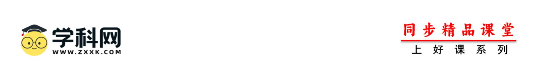2．How long should homework for middle school students take?
3．Can middle school students bring mobile phones to class?
4．What should students do to master the right ways of learning according to the passage?
5．How many rules are talked about in this passage?
阅读短文，然后根据内容回答问题。
Cindy is not happy now. She wants to take a trip to a beautiful village with her classmates this Saturday, but
her parents don’t allow her to go.
Her parents are a little strict with her. She must follow the family rules. She must finish: her homework
before she listens to music. She can’t watch TV or read a storybook on school nights. On Sunday mornings, she
must learn to make some delicious food from her mother... She can play the piano on Sunday afternoons and she is
good at it.
She also has to follow the school rules. She can’t be late for school. It takes her about twenty minutes to get
to school on foot every weekday. She must keep her hair short. She can’t run in the classroom or in the hallways
because it’s quite dangerous. Sometimes she can’t stand (忍受) some of these rules. Cindy’s best friend helps her
know that her parents and teachers make these rules to help her. Now she thinks the rules are useful.
1．Where does Cindy want to go this Saturday?
2．Who teaches Cindy to make delicious food?
3．How does Cindy go to school?
4．What family rules do you have? What do you think of them? Write 30 words or more.
Dear students,
同步新教材，周周有练习，月月有重点！ 8

The following rules are for living and working in No.1 Middle School. Please read them carefully.
1. Stand up when a teacher or a visitor goes into the room.
2. You must be in the classroom or other study places during lesson time.
3. Arrive on time for the start of each lesson with the things you need so that you are ready to start work.
4. Wear smart, clean clothes. Hair must be clean and tidy. Extreme colors and styles are not allowed. Long
hair must be tied back neatly.
5. Do not leave school if you are not allowed.
6. Food and drink must not be taken out from the dining room.
7. All medicine must be given by the school doctor.
8. Radio s and personal computers may only be used in dormitory houses where the house rules allow. They
are not allowed in class or in the library.
No.1 Middle School
根据语篇内容回答问题（每小题答案不超过 4 个单词）
1．Can students go outside the school on Wednesday?
2．What should the students do when a teacher or a visitor goes into the room?
3．Where must the students have their lunch and supper?
4．Where can the students use their personal computers?
5．Can the students be late for the start of each lesson?
Li Yong is my pen friend from Shanghai. She tells me that she has too many rules in her house. She has to get
up at half past six every morning. She can’t see her friends after school because she has to do her homework. She
can’t watch TV or play computer games on school nights. And she has to be in bed before nine o’clock. Only on
weekends she can go to bed before ten o’clock. She has to clean her room and wash her clothes on weekends. Then
she has to help her mother make dinner. She has to go to the Children’s Palace to learn the piano on Sunday
afternoon. She tells me she never has any fun.
同步新教材，周周有练习，月月有重点！ 9

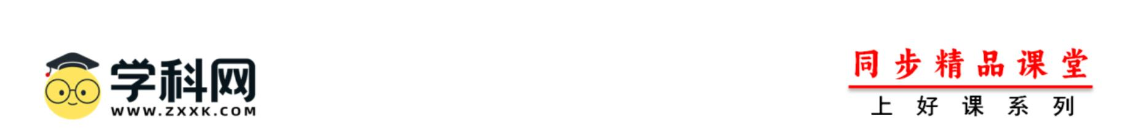1．What time does Li Yong have to get up?
2．Li Yong can’t watch TV or play computer games on school night, can she?
3．What time can Li Yong be in bed on Friday?
4．Where does Li Yong learn the piano on Sunday afternoon?
5．What does Li Yong think of the rules in her house?
It is popular to ride a bike to school, but there is a new rule for riding a bike in Taiwan—all the middle school
students must have a test of riding a bike.
The test is not difficult. There are two parts: a written test and a road test. For the first test, there are 6-hour
lessons for them. Students can learn traffic rules and structure(结构) of a bike.
Before the road test, students must learn to ride a bike on S-shaped road or a rough(不平坦的) road. Teachers
help them to practicing riding a bike. When students pass the test, they can get a license(执照) for riding a bike.
The test is good for students to go to school happily and come back home safely.
1．What are the two parts of the test?
2．What can students learn from the 6-hour lessons?
3．What must the students do before the road test?
4．Can students get a license after they pass the test?
5．What is the test good for?
The Rules in American Schools
同步新教材，周周有练习，月月有重点！ 10

Greetings
You needn’t greet your teachers when you come into a very big class. If you are late for class, you may go into
the classroom quietly. But you should say sorry to the teacher after class.
Answering questions
Don’t talk when somebody else is speaking. If you have something to say, you have to wait. When someone is
speaking, you shouldn’t interrupt him or her. If you want to answer the teacher’s questions, you may stand up and
speak loudly. It’s impolite to keep quiet when your teacher asks you questions. If you don’t know the answers, you
can say “I’m sorry.”
Other interesting rules
Some American schools don’t allow students to wear caps, sunglasses or the large trousers. And they can’t
bring any bananas to school. The school bags for the students are usually sheer (透明的), so teachers can find what’
s in it easily.
1．If you are late for class in American schools, what should you do?
2．Is it polite to talk when someone else is speaking?
3．When students want to answer the teacher’s questions, what should they do?
4．In some American schools, students can’t do somethings. Give an example.
5．Why are the students’ bags sheer in some American schools?
请阅读下面这篇文章，根据所提供的信息回答问题。要求所写答案语法正确、语义完整。
There are many rules for Jen. She thinks some of them are good. At home, she must get up early for running.
She has to make her bed. At school, she can’t arrive late. She can’t run in the hallways, and she can’t eat in class.
All these rules are okay because they’re good for her.
But there are some rules Jen doesn’t like. At home, she can’t watch TV on weekends; she must do her
homework all the time. She must read a book after dinner and she can’t talk with friends on WeChat. On
schooldays she has to wear the school uniform and she can’t wear jeans. But she likes jeans because she thinks they
同步新教材，周周有练习，月月有重点！ 11

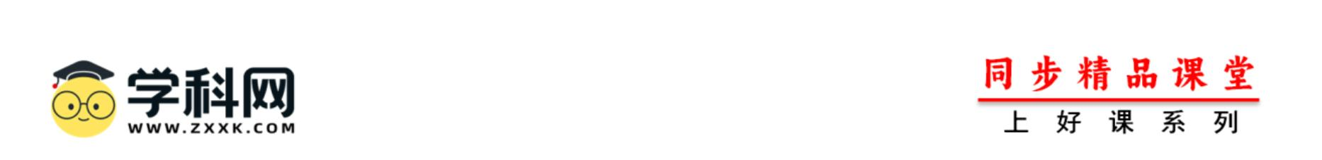are cool. She can’t listen to music in the art class but she thinks listening to music in the art class is okay.
1．Does Jen have to make her bed at home?
2．How many school rules does Jen think are okay?
3．What must Jen do after dinner?
4．When do the students have to wear the school uniform?
5．Why does Jen like jeans?
阅读下面的文章。请根据问题提示，用自己的话回答问题。
Dear Dr. Know,
There are too many rules! At 6:00 a.m., my mom says, “Get up now and make your bed!” After breakfast, my
mom always says, “Don’t leave the dirty dishes in the kitchen!”
After that, I run to school because I can’t be late. At school, we have more rules—don’t be noisy, don’t eat in
class, …
My dad says I can’t play basketball after school because I must do my homework. I can play only on
weekends. After dinner, I can’t relax either. I must read a book before I can watch TV. But I have to go to bed
before 10:00. Rules, rules, rules! It’s terrible! What can I do, Dr. Know?
Molly Brown, New York
1．When does Molly Brown get up?
2．What does Molly Brown’s mother always say?
3．Why does Molly Brown run to school?
4．Can Molly Brown eat in class?
同步新教材，周周有练习，月月有重点！ 12

5．Why does Molly Brown’s father say she can’t play basketball?
同步新教材，周周有练习，月月有重点！ 13

